App Service VNet Integration – DNS Connectivity Assessment
Environment: Azure Government (US Gov Virginia)
Prepared by: Ashenafi Gurmu
Audience: Cloud / Network / Cyber Administration
Purpose: Identify and resolve DNS connectivity failure impacting App Service Private Endpoint access

1. Executive Summary
An Azure App Service deployed in the Risk Decision directory and integrated with a virtual network is unable to resolve any external or Private Endpoint–backed service endpoints (e.g., Azure Blob Storage, Azure OpenAI, Azure Cognitive Search).
The failure occurs at the DNS transport layer, prior to TLS or certificate validation.
Testing from within the App Service confirms that outbound DNS traffic from the VNet integration subnet cannot reach the configured corporate DNS servers.
As a result, all hostname resolution fails, blocking access to Private Endpoints and Azure service FQDNs.

2. Scope of Testing
Testing was performed from inside the App Service runtime (Kudu / SSH), not from a VM or local machine, ensuring results accurately reflect the production execution environment.
App Service Details
- App Service: test-ashe
- Integration Subnet: development-usgovvirginia-subnet-2-public
- VNet: vnet-development-usgovvirginia
- DNS Servers (VNet-level): 10.33.32.4, 10.33.32.5
- NSG attached to subnet: nsg-development-usgovvirginia-subnet_2_public
- Route Table: None

3. Observed Behavior (Facts)
3.1 DNS Configuration Inside App Service
From /etc/resolv.conf inside the App Service container:
# This container is using an embedded dns resolver
# The configured nameservers at startup are 10.33.32.4, 10.33.32.5
nameserver 127.0.0.11
Interpretation (factual):
- App Service uses an embedded DNS resolver (127.0.0.11)
- This resolver forwards DNS queries to:
  - 10.33.32.4
  - 10.33.32.5

3.2 DNS Resolution Tests (Inside App Service)
All DNS queries time out:
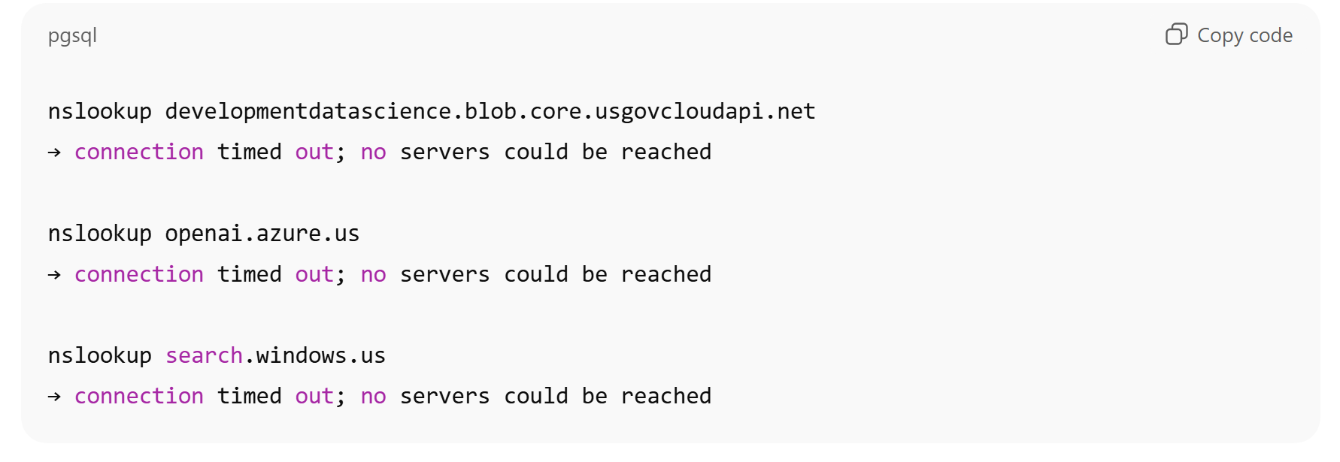

3.3 Direct Connectivity Test to DNS Servers
Direct TCP connectivity test to DNS servers on port 53:
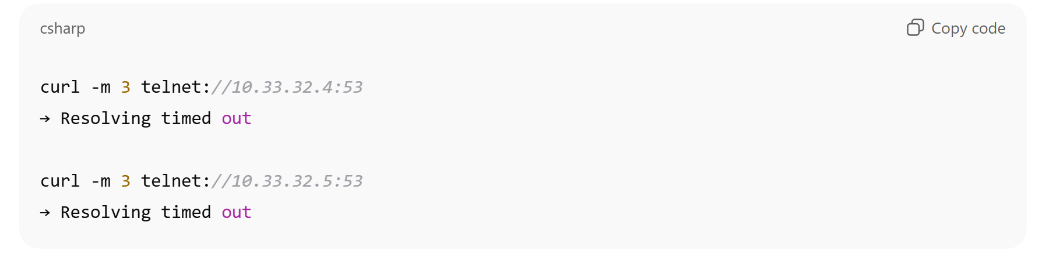
Conclusion:
The App Service integration subnet cannot establish network connectivity to the DNS servers on port 53.

4. What Is NOT the Problem (Ruled Out)
Based on the above evidence, the following are not contributing factors:
- ❌ Private Endpoint creation (endpoints exist)
- ❌ Private DNS zone presence (zones are created and linked)
- ❌ TLS / CA trust
- ❌ Certificate chain configuration
- ❌ Storage account naming or endpoint typos
- ❌ Application code
DNS resolution fails before any of these layers are reached.

5. Root Cause (Proven)
The App Service VNet Integration subnet cannot reach the configured corporate DNS servers (10.33.32.4, 10.33.32.5) on UDP/TCP port 53.
This is a network reachability issue, likely caused by one or more of the following:
- Missing outbound DNS allow rules on the subnet NSG
- Central firewall / NVA blocking DNS traffic
- DNS servers not permitting traffic from the App Service integration subnet
- Forced inspection path not allowing UDP/TCP 53

6. Why TLS / CA Is Not Relevant at This Stage
TLS validation occurs after hostname resolution.
In this case:
- Hostnames never resolve
- No IP address is returned
- TLS handshake is never initiated
Therefore, certificate trust does not apply until DNS connectivity is restored.

7. Required Network Configuration (Minimal)
To restore functionality, the following must be allowed:
Direction | Protocol | Port | Source Subnet | Destination
Outbound | UDP | 53 | development-usgovvirginia-subnet-2-public | 10.33.32.4
Outbound | UDP | 53 | development-usgovvirginia-subnet-2-public | 10.33.32.5
Outbound | TCP | 53 | development-usgovvirginia-subnet-2-public | 10.33.32.4
Outbound | TCP | 53 | development-usgovvirginia-subnet-2-public | 10.33.32.5
This can be implemented via:
- NSG outbound rules and/or
- Firewall / NVA policy

8. Validation Criteria (Post-Fix)
Once DNS access is restored, the following test should succeed immediately from inside the App Service:
nslookup developmentdatascience.blob.core.usgovcloudapi.net
Expected result:
- Successful resolution (public or private IP depending on Private Endpoint wiring)
Only after this succeeds should:
- curl
- SDK calls
- TLS / CA validation
be tested.

9. Summary
- The App Service deployment is correct
- Private Endpoints and DNS zones exist
- The failure is at DNS transport level
- The issue is network-level and external to the application
- Resolution requires enabling outbound DNS from the integration subnet

